Q1.
A student investigated how the current in a filament lamp varies with the potential difference across the lamp.
Figure 1 shows the circuit used.
Figure 1
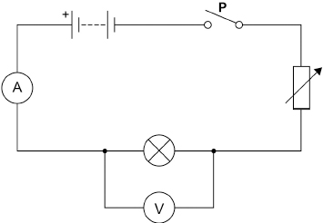
(a) What is component P?
___________________________________________________________________
(1)
(b) Complete the sentences.
Choose answers from the box.

charge | current | energy | potential difference | power
The ammeter in the circuit measures ____________________.
The voltmeter in the circuit measures ____________________.
(2)
(c) How will increasing the resistance of the variable resistor in Figure 1 affect each of the following quantities?
Tick (✓) one box in each row.

Quantity | Decreases | Stays the same | Increases
Current in the circuit
Potential difference across the lamp
Total resistance of the circuit
(3)
(d) A charge flow of 15 coulombs passed through the filament lamp in a time of 60 seconds.
Calculate the current in the lamp.
Use the equation:
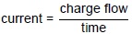
___________________________________________________________________
___________________________________________________________________
___________________________________________________________________
Current = ____________________ A
(2)
(e) When the current in the filament lamp is 0.12 A, the potential difference across the lamp is 6.0 V.
Calculate the resistance of the filament lamp.
Use the equation:
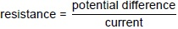
___________________________________________________________________
___________________________________________________________________
___________________________________________________________________
Resistance = ____________________ Ω
(2)
(f) The student repeated the investigation after replacing the lamp with a resistor at constant temperature and then a diode.
The student plotted a graph for each component.
Draw one line from each component to its graph.
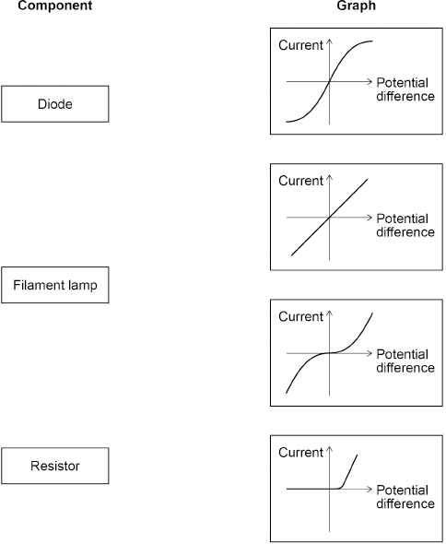
(2)
(g) Figure 2 shows an ammeter.
The ammeter is not connected to a circuit.
Figure 2
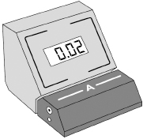
What type of error does the ammeter display?
Tick (✓) one box.

A positive error | 
A random error
A zero error
(1)
(Total 13 marks)
Q2.
(a) The lamps in the circuits drawn below are all identical.
Each of the cells has a potential difference of 1.5 volts.
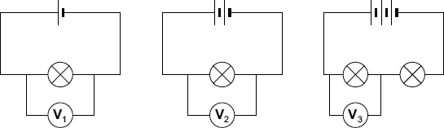
(i) What is the potential difference across the 3 cells that are joined in series?
______________________________________________________________
Potential difference = _________________________ V
(1)
(ii) What will be the reading on the voltmeter labelled V_{3?}
Voltmeter reading V₃ = _________________________ V
(1)
(iii) Which voltmeter, V₁, V₂ or V₃, will give the highest reading?
Draw a ring around your answer.

V₁ | V₂ | V₃
(1)
(b) The diagram below shows a simple circuit.
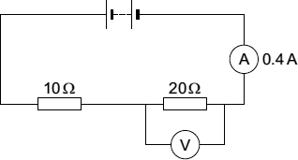
(i) Calculate the total resistance of the two resistors in the circuit.
______________________________________________________________
Total resistance = _________________________ Ω
(1)
(ii) Use the equation in the box to calculate the reading on the voltmeter.

potential difference = current × resistance
Show clearly how you work out your answer.
______________________________________________________________
______________________________________________________________
Voltmeter reading = _________________________ V
(2)
(iii) The current through a resistor at constant temperature changes when the potential difference across the resistor changes.
Which one of the graphs, X, Y or Z, shows how the current changes?
Write your answer, X, Y or Z, in the box.

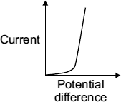  X | 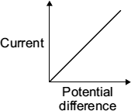  Y | 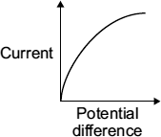  Z
Graph 
(1)
(Total 7 marks)
Q3.
Most electric kettles use the ac mains electricity supply.
(a) Complete the sentence.
The ac mains supply has a potential difference that continuously
____________________ polarity
(1)
Figure 1 gives the power output of three electric kettles.
Figure 1
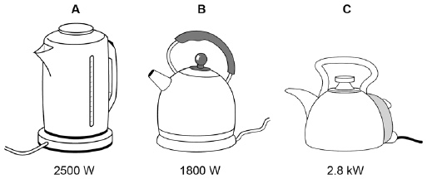
A student investigated how the power output of a kettle affected the time taken to boil a fixed volume of water.
The water in all three kettles had an initial temperature of 25 °C.
(b) What type of variable was the time?
Tick one box.

Control | 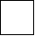
Dependent
Independent
(1)
(c) Which kettle will boil the water in the shortest time?
Give a reason for your answer.
Kettle ______________________________________________________________
Reason ____________________________________________________________
___________________________________________________________________
___________________________________________________________________
(2)
(d) Figure 2 shows how the amount of energy transferred by a kettle varies with time.
Figure 2
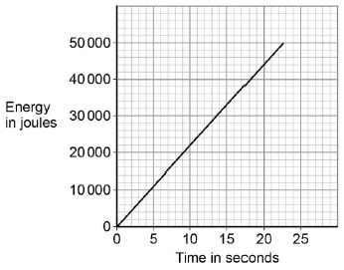
The power output of the kettle is given by the gradient of the graph.
Calculate the power output of the kettle.
___________________________________________________________________
___________________________________________________________________
Power output = ____________________ W
(2)
(e) Write down the equation that links charge flow, current and time.
___________________________________________________________________
(1)
(f) Calculate the current through the kettle when 2400 coulombs of charge flows in 250 seconds.
___________________________________________________________________
___________________________________________________________________
___________________________________________________________________
___________________________________________________________________
Current = ____________________ A
(3)
(Total 10 marks)
Q4.
A student investigated how the current in a circuit varied with the number of lamps connected in parallel in the circuit.
Figure 1 shows the circuit with three identical lamps connected in parallel.
Figure 1
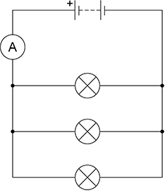
Figure 2 shows the results.
Figure 2
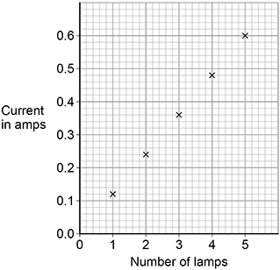
(a) Complete the sentences.
Choose answers from the box.
Each answer can be used once, more than once or not at all.

decreased | stayed the same | increased
As the number of lamps increased, the current __________________.
As the number of lamps increased, the total resistance of the circuit
_____________________ .
As the number of lamps increased, the potential difference across the battery
_____________________ .
(3)
(b) When there were three lamps in the circuit the ammeter reading kept changing between 0.35 A and 0.36 A.
What type of error would this lead to?
Tick (✓) one box.

Random error
Systematic error
Zero error
(1)
Figure 3 shows a circuit with five ammeters and three identical lamps.
Figure 3
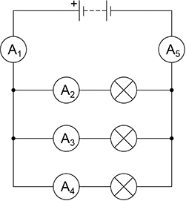
(c) Complete the table below to show the readings on ammeters A₂ and A₅.

Ammeter | A₁ | A₂ | A₃ | A₄ | A₅
Current in amps | 0.36 |  | 0.12 | 0.12
(2)
(d) The resistance of one lamp is 15 Ω.
The current in the lamp is 0.12 A.
Calculate the power output of the lamp.
Use the equation:
power = (current)² × resistance
___________________________________________________________________
___________________________________________________________________
___________________________________________________________________
Power = _______________ W
(2)
(Total 8 marks)
Q5.
The diagram shows the circuit set up by a student.
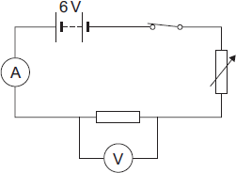
(a) The student uses the circuit to test the following hypothesis:
‘The current through a resistor is directly proportional to the potential difference across the resistor.’
(i) If the hypothesis is correct, what should the student predict will happen to the current through the resistor when the potential difference across the resistor is doubled?
______________________________________________________________
______________________________________________________________
(1)
(ii) Name the component in the circuit used to change the potential difference across the resistor.
______________________________________________________________
(1)
(b) The student used the data obtained to plot the points for a graph of current against potential difference.
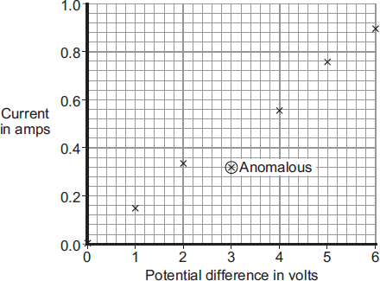
(i) Why has the student plotted the points for a line graph and not drawn a bar chart?
______________________________________________________________
______________________________________________________________
(1)
(ii) One of the points has been identified by the student as being anomalous.
What is the most likely cause for this anomalous point?
______________________________________________________________
______________________________________________________________
(1)
(iii) Draw a line of best fit for these points.
(1)
(iv) Does the data the student obtained support the hypothesis?
Give a reason for your answer.
______________________________________________________________
______________________________________________________________
(1)
(Total 6 marks)
Q6.
(a) The diagram shows the circuit used to obtain the data needed to plot the current–potential difference graph for a filament bulb.
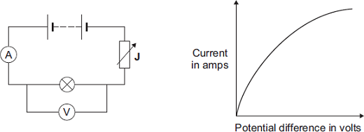
(i) Why is the component labelled ‘J’ included in the circuit?
______________________________________________________________
______________________________________________________________
(1)
(ii) The resistance of the bulb increases as the potential difference across the bulb increases. Why?
______________________________________________________________
______________________________________________________________
(1)
(iii) The bulb is at full brightness when the potential difference across the bulb is 12 V.
The current through the bulb is then 3 A.
Calculate the power of the bulb when it is at full brightness and give the unit.
______________________________________________________________
______________________________________________________________
______________________________________________________________
Power = _________________________
(3)
(b) In this question you will be assessed on using good English, organising information clearly and using specialist terms where appropriate.
The table gives data about two types of light bulb people may use in their homes.

Type of light bulb | Energy efficiency | Cost of one light bulb | Average lifetime in hours
Halogen | 10% | £1.95 | 2 000
Light Emitting Diode (LED) | 32% | £11.70 | 36 000
Both types of light bulb produce the same amount of light.
Evaluate, in terms of cost and energy efficiency, the use of the two types of light bulb.
To gain full marks you must compare both types of light bulb and conclude which light bulb would be the best to use.
___________________________________________________________________
___________________________________________________________________
___________________________________________________________________
___________________________________________________________________
___________________________________________________________________
___________________________________________________________________
___________________________________________________________________
___________________________________________________________________
___________________________________________________________________
(6)
(Total 11 marks)
Q7.
(a) Figure 1 shows the current−potential difference graph for three wires, A, B and C.
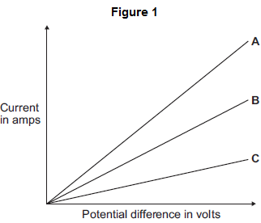
(i) Using Figure 1, how can you tell that the temperature of each wire is constant?
______________________________________________________________
______________________________________________________________
(1)
(ii) Which one of the wires, A, B or C, has the greatest resistance?

Write the correct answer in the box. | 
Give a reason for your answer.
______________________________________________________________
______________________________________________________________
______________________________________________________________
(2)
(b) A student measured the resistance of four wires.
The table below shows the resistance of, and other data about, each of the four wires, J, K, L and M.

Wire | Type of  metal | Length  in cm | Diameter  in mm | Resistance  in …….
J | copper | 50 | 0.17 | 0.36
K | copper | 50 | 0.30 | 0.12
L | copper | 100 | 0.30 | 0.24
M | constantan | 100 | 0.30 | 7.00
(i) The last column of the table should include the unit of resistance.
What is the unit of resistance?
______________________________________________________________
(1)
(ii) The resistance of a wire depends on many factors.
Look at the table. Which two wires from J, K, L and M show that the resistance of a wire depends on the length of the wire?

Wire |  | and wire
Give a reason for your answer.
______________________________________________________________
______________________________________________________________
______________________________________________________________
(2)
(iii) A student looked at the data in the table and wrote this conclusion:
‘The resistance of a wire depends on the type of metal from which the wire is made.’
The student could not be certain that her conclusion is true for all types of metal.
Suggest what extra data is needed for the student to be more certain that the conclusion is correct
______________________________________________________________
______________________________________________________________
______________________________________________________________
(1)
(c) The resistance of a wire can be calculated using the readings from an ammeter and a voltmeter.
(i) Complete Figure 2 by drawing a voltmeter in the correct position in the circuit. Use the correct circuit symbol for a voltmeter.
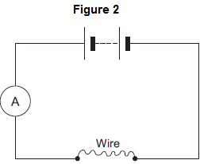
(1)
(ii) In a circuit diagram, a wire can be represented by the symbol for a resistor.
In the box below, draw the circuit symbol for a resistor.

(1)
(Total 9 marks)
Q8.
A student investigated how the resistance of a piece of nichrome wire varies with length.
Figure 1 shows part of the circuit the student used.
Figure 1
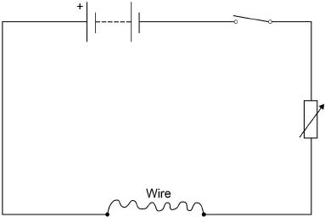
(a) Complete Figure 1 by adding an ammeter and a voltmeter.
Use the correct circuit symbols.
(3)
(b) Describe how the student would obtain the data needed for the investigation.
Your answer should include a risk assessment for one hazard in the investigation.
___________________________________________________________________
___________________________________________________________________
___________________________________________________________________
___________________________________________________________________
___________________________________________________________________
___________________________________________________________________
___________________________________________________________________
___________________________________________________________________
___________________________________________________________________
___________________________________________________________________
___________________________________________________________________
___________________________________________________________________
(6)
(c) Why would switching off the circuit between readings have improved the accuracy of the student’s investigation?
Tick one box.

The charge flow through the wire would not change. | 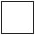
The potential difference of the battery would not increase.
The power output of the battery would not increase.
The temperature of the wire would not change.
(1)
(d) The student used crocodile clips to make connections to the wire.
They could have used a piece of equipment called a ‘jockey’.
Figure 2 shows a crocodile clip and a jockey in contact with a wire.
Figure 2
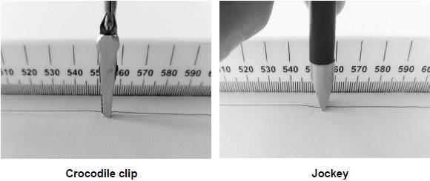
How would using the jockey have affected the accuracy and resolution of the student’s results compared to using the crocodile clip?
Tick two boxes.

The accuracy of the student’s results would be higher.
The accuracy of the student’s results would be lower.
The accuracy of the student’s results would be the same.
The resolution of the length measurement would be higher.
The resolution of the length measurement would be lower.
The resolution of the length measurement would be the same.
(2)
(Total 12 marks)
Q9.
In a hairdryer circuit there is a heater and a motor. It is important that the motor is always running when the heater is switched on.
(a) Using the symbols shown below only once each, draw a circuit for a hairdryer.

(2)
(b) Modern hairdryers are described as double insulated.
Explain what this term means.
___________________________________________________________________
___________________________________________________________________
___________________________________________________________________
(2)
(c) On a modern hairdryer handle it states:
1600 W 230 V 50 Hz
(i) [A] Write an equation which shows the relationship between current, power and voltage.
_________________________________________________________
(1)
[B] Calculate the current in the hairdryer when it is on full power.
Show clearly how you get your answer.
_________________________________________________________
_________________________________________________________
Current = ______________ A
(2)
(ii) [A] Write an equation which shows the relationship between current, resistance and voltage.
_________________________________________________________
(1)
[B] The resistance of the heater is 20 ohms. Calculate the resistance of the motor.
Show clearly how you get your answer.
_________________________________________________________
_________________________________________________________
Resistance = ________ ohms
(2)
(Total 10 marks)
Q10.
When a mains lamp is switched on it takes 0.5 seconds for the filament to reach its normal operating temperature. The way in which the current changes during the first second after switching on is shown in the sketch graph below. Mains voltage is 240 V.
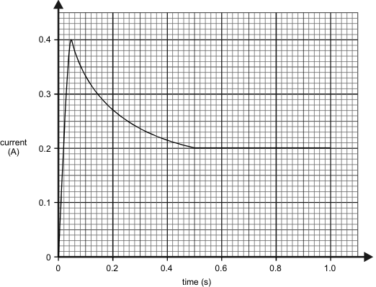
(a) Calculate the resistance of the filament whilst the lamp is drawing the maximum current.
___________________________________________________________________
___________________________________________________________________
___________________________________________________________________
(3)
(b) Describe how the resistance of the lamp changes after the current has reached its maximum value.
___________________________________________________________________
___________________________________________________________________
(2)
(c) Calculate the maximum power taken by the lamp.
___________________________________________________________________
___________________________________________________________________
___________________________________________________________________
(2)
(d) Calculate the power of the lamp in normal use.
___________________________________________________________________
___________________________________________________________________
___________________________________________________________________
(2)
(e) Calculate the energy used by the lamp in six hours of normal use.
___________________________________________________________________
___________________________________________________________________
___________________________________________________________________
(3)
(Total 12 marks)
Q11.
The following specification is taken from the instruction booklet of a combination microwave oven.

AC voltage | 240 V 50 Hz
Power required
Microwave | 1.5 kW
Dual (Roast/Bake) | 2.8 kW
Dual (Grill) | 2.5 kW
Convection | 1.35 kW
Grill | 2.3 kW
Output power
Microwave | 850 W
Convection heater | 1350 W
Grill heater | 1000 W
Microwave frequency | 2450 MHz
(a) (i) What is the current when the oven is being used to cook in the dual (roast/bake) mode? Show clearly how you work out your answer.
______________________________________________________________
______________________________________________________________
Current = _________________ A
(2)
(ii) Calculate the resistance of this combination microwave oven when it is being used in the dual (roast/bake) mode. Show clearly how you work out your answer and give the units.
______________________________________________________________
______________________________________________________________
______________________________________________________________
Resistance = ________________
(3)
(b) What is the percentage efficiency of the oven when it is working in the microwave mode?
___________________________________________________________________
___________________________________________________________________
___________________________________________________________________
Percentage efficiency = _________________ %
(2)
(Total 7 marks)
Q12.
(a) Complete the sentence. Choose answers from the box.

charge | potential difference | power | temperature | time
The current through an ohmic conductor is directly proportional to the
_______________________ across the component, provided
that the _______________________ remains constant.
(2)
(b) Figure 1 shows a current − potential difference graph for a filament lamp.
Figure 1
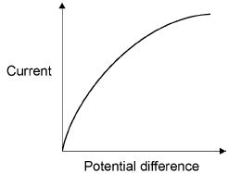
Explain how the resistance of a filament lamp changes as the potential difference across it increases.
___________________________________________________________________
___________________________________________________________________
___________________________________________________________________
___________________________________________________________________
___________________________________________________________________
___________________________________________________________________
(3)
(c) Many householders are replacing their filament lamps with LED lamps which are more energy efficient.
What does more energy efficient mean?
___________________________________________________________________
___________________________________________________________________
___________________________________________________________________
(1)
A Light Dependent Resistor (LDR) is used to turn on an outside lamp when it gets dark.
Part of the circuit is shown in Figure 2.
Figure 2
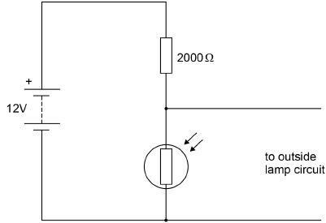
(d) The light intensity decreases.
What happens to the potential difference across the LDR and the current in the LDR?
Potential difference ___________________________________________________
Current ____________________________________________________________
(2)
(e) What is the resistance of the LDR when the potential difference across it is 4 V?
Give a reason for your answer.
Explain your answer.
Resistance = _______________________ Ω
Reason ____________________________________________________________
___________________________________________________________________
___________________________________________________________________
(2)
(f) Calculate the current through the LDR when the resistance of the LDR is 5000 Ω.
Give your answer to 2 significant figures.
___________________________________________________________________
___________________________________________________________________
___________________________________________________________________
___________________________________________________________________
Current = _______________________ A
(4)
(Total 14 marks)

Mark schemes
Q1.
(a) switch
1
(b) current
1
potential difference
allow p.d.
allow voltage
1
in this order only
(c)
Quantity | Decrease | Stay the same | Increase
Current in the circuit | ✓
Potential difference across the lamp | ✓
Total resistance of the circuit |  |  | ✓
any extra tick in a row negates the mark for that row
3
(d) 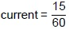
1
current = 0.25 (A)
1
(e) 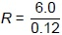
1
R = 50 (Ω)
1
(f)
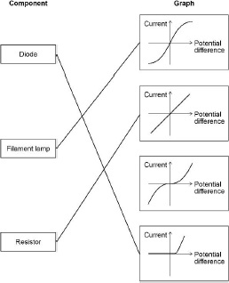
2 marks for all 3 correct
1 mark for 1 or 2 correct
additional line from a box on the left negates the mark for that box
2
(g) a zero error
1
[13]
Q2.
(a) (i) 4.5
1
(ii) 2.25 or their (a)(i) ÷ 2 correctly calculated
1
(iii) V₂
1
(b) (i) 30
1
(ii) 8
allow 1 mark for correct substitution
ie 0.4 × 20
allow 1 mark for answers of 4 or 12
2
(iii) Y
1
[7]
Q3.
(a) changes
allow reverses
1
(b) dependent
1
(c) kettle C
or
2.8 kW
1
highest power (output)
allow higher power (output)
1
(d) values for gradient calculation shown on graph or on answer lines
1
power input = 2200 (W)
accept an answer that rounds to 2200 (W) for 2 marks
1
(e) charge flow = current × time
allow Q = It
1
(f) 2400 = I × 250
1
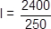
1
I = 9.6 (A)
an answer of 9.6 (A) scores 3 marks
1
[10]
Q4.
(a) increased
1
decreased
1
stayed the same
1
(b) random error
1
(c) A₂ = 0.12 (A)
1
A₅ = 0.36 (A)
1
(d) P = 0.12² × 15
1
P = 0.216 (W)
1
[8]
Q5.
(a) (i) also double
increases is insufficient
1
(ii) variable resistor
accept rheostat / potentiometer
1
(b) (i) the data / results / variables are continuous
accept data / results / variables are not categoric / discrete
1
(ii) misreading the ammeter
do not accept misreading the meter / results
do not accept misreading the ammeter and / or voltmeter
reading / human error is insufficient
1
(iii) straight line from the origin drawn passing close / through
points at 1 V, 5 V, 6 V and ignoring anomalous point
do not accept line drawn ‘dot-to-dot’
1
(iv) yes
mark is for the reason
supports prediction
or
(straight) line passes through the origin
accept a mathematical argument, eg when p.d. went from 2 to 4 the current went from 0.3 to 0.6
it’s directly proportional is insufficient
1
[6]
Q6.
(a) (i) to obtain a range of p.d. values
accept increase / decrease current / p.d. / voltage / resistance
accept to change / control the current / p.d. / voltage / resistance
to provide resistance is insufficient
a variable resistor is insufficient
do not accept electricity for current
1
(ii) temperature of the bulb increases
accept bulb gets hot(ter)
accept answers correctly
expressed in terms of collisions between (free) electrons and ions / atoms
bulb gets brighter is insufficient
1
(iii) 36
allow 1 mark for correct substitution, ie 12 × 3 provided no subsequent step shown
2
watt(s) / W
accept joules per second / J/s
do not accept w
1
(b) Marks awarded for this answer will be determined by the Quality of Written Communication (QWC) as well as the standard of the scientific response. Examiners should also refer to the information in the Marking guidance, and apply a ‘best-fit’ approach to the marking.
0 marks
No relevant content.
Level 1 (1-2 marks)
There is a basic comparison of either a cost aspect or an energy efficiency aspect.
Level 2 (3-4 marks)
There is a clear comparison of either the cost aspect or energy efficiency aspect
OR
a basic comparison of both cost and energy efficiency aspects.
Level 3 (5-6 marks)
There is a detailed comparison of both the cost aspect and the energy efficiency aspect.
For full marks the comparisons made should support a conclusion as to which type of bulb is preferable.
Examples of the points made in the response:
cost
• halogen are cheaper to buy
simply giving cost figures is insufficient
• 6 halogen lamps cost the same as one LED
• LEDs last longer
• need to buy 18 / more halogen lamps to last the same time as one LED
• 18 halogens cost £35.10
• costs more to run a halogen than LED
• LED has lower maintenance cost (where many used, eg large departmental store lighting)
energy efficiency
• LED works using a smaller current
• LED wastes less energy
• LEDs are more efficient
• LED is 22% more energy efficient
• LED produces less heat
• LED requires smaller input (power) for same output (power)
6
[11]
Q7.
(a) (i) p.d. is (directly) proportional to current
or
gradient / slope is constant
or
the lines show constant resistance
accept lines are straight / diagonal
1
(ii) C
reason only scores if C is chosen
1
for the same p.d. the current is the smallest
accept lowest gradient and the gradient = 1 / R
1
(b) (i) ohm
accept correct symbol Ω
accept an answer written in the table if not given in answer space
1
(ii) K and L
reason only scores if both K and L are chosen
1
only length varies
accept type of metal and the diameter are the same
1
(iii) measure the resistance of more wires made from different metals
accept test more (types of) metals
measure the resistance of more wires is insufficient
they only use two metals is insufficient
1
(c) (i) voltmeter symbol correct and drawn in parallel with the wire
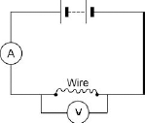
accept voltmeter symbol correct and drawn in parallel with the battery
1
(ii) correct symbol drawn
symbol must be rectangular
1
[9]
Q8.
(a) ammeter and voltmeter symbols correct
1
voltmeter in parallel with wire
1
ammeter in series with wire
1
(b) Level 3: The method would lead to the production of a valid outcome. All key steps are identified and logically sequenced.
5−6
Level 2: The method would not necessarily lead to a valid outcome. Most steps are identified, but the method is not fully logically sequenced.
3−4
Level 1: The method would not lead to a valid outcome. Some relevant steps are identified, but links are not made clear.
1−2
No relevant content
0
Indicative content
• length measured
• length varied
• current measured
• potential difference measured
• repeat readings
• calculate resistance for each length
• 
• plot a graph of resistance against length
• hazard: high current
• may cause wire to melt / overheat
• may cause burns (to skin)
• use low currents
(c) the temperature of the wire would not change
1
(d) the accuracy of the student’s results would be higher
1
the resolution of the length measurement would be higher
1
[12]
Q9.
(a) series circuit
all four components must be included
if a battery included the neatness mark may still be awarded
1
circuit fully functional or properly connected
this is the neatness mark
do not credit a parallel circuit with one switch controlling both components
1
(b) case or outer parts are made of plastic or insulator or non-metallic
1
there is no electrical pathway between inner and outer insulation
accept no connection between inner and outer part
do not credit two layers of insulation
1
(c) (i) [A] power = voltage × current
accept P = V I or
W = V × A
or any transformation
1
[B] 1600 ÷ 230 =current
1
6.96 or 7
accept with no working for two marks
accept 6.95
in [A] award a mark for a triangle if calculation correctly performed
1
(ii) [A] voltage = current × resistance
accept V = I R or any transformation
1
[B] 230 ÷ 7 = overall R = 33
accept 230 ÷ 6.96 = overall R = 33
1
resistance of motor = 33 – 20 = 13
accept with no working for two marks
do not credit negative answer
accept consequential errors from c(i)
in [A] award a mark for a triangle if calculation correctly performed
1
[10]
Q10.
(a) Current = 0.4A (1)
R = V/I or 240/0.4 (1)
R = 600 ohm (1)
3
(b) Doubles
gets 2 marks
OR gets bigger
gets 1 mark
2
(c) P = V.I or 240 × 0.4
P = 96W
for 1 mark each
2
(d) 1 = 0.2A
P = 48W
for 1 mark each
BUT may get equation mark here if not in (c)
2
(e) P = V.I.t (1)
P = 240 × 0.2 × 6 × 3600
OR P = 48 × 6 × 3600
gets 1 mark
P = 1036800 W
gets 1 mark
3
[12]
Q11.
(a) (i) power ÷ voltage = current or
2800 ÷ 240 = 11.6 – 11.7 or 12
2 marks for correct answer 1 mark for 2.8 ÷ 240
2
(ii) resistance = voltage ÷ current
240 ÷ 11.7
(efc here)
1
20.5 or 20.57 or 20.6 or 21
2 marks for correct answer
1
ohms or Ω
do not credit R
1
(b) 850 ÷ 1500 × 100
marks only available for division of power
1
= 56.7
2 marks for correct answer
for 1 mark accept 5670
1
[7]
Q12.
(a) potential difference
allow p.d.
allow voltage
1
temperature
1
in this order only
(b) the current increases (when the potential difference increases)
1
(which) causes the temperature of the filament to increase
1
(so) the resistance increases
do not accept resistance increases and then levels off
1
(c) a higher proportion / percentage of the (total) power / energy input is usefully transferred
wastes less energy is insufficient
or
higher (useful) power / energy output for the same (total) power / energy input
1
(d) potential difference increases
1
current decreases
1
(e) 1000 (Ω)
reason only scores if R = 1000 (Ω)
1
potential difference is shared in proportion to the resistance
allow a justification using a correct calculation
1
(f) 12 = I × 7000
1
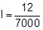
1
I = 1.71 × 10⁻³ (A)
an answer that rounds to 1.7 × 10⁻³ (A) scores 3 marks
1
I = 1.7 × 10⁻³ (A)
this answer only
or
I = 0.0017 (A)
an answer of 2.4 × 10⁻³ (A) scores 2 marks
if no other marks scored allow 1 mark for calculation of total resistance (7000 Ω)
1
an answer of 1.7 × 10⁻³ (A) scores 4 marks
[14]

